Story 2 – Technical Implementation Using Power BI

1. Power BI Desktop – Data Import & Setup
- How you imported the dataset?
  - The dataset was imported into Power BI Desktop using the Get Data option.
  - Excel workbook was selected as the data source and the sales data tables (such as People, Products, Shipments, Calendar, and Locations) were loaded into the Power BI data model.
  - After selecting the required sheets/tables, Transform Data was used to open Power Query Editor for cleaning and structuring.
- initial structuring done as:
  - Unnecessary columns were removed to improve model performance.
  - Column names were formatted properly for consistency (e.g. removing spaces, renaming headers).
  - Data types were corrected (Date fields → Date type, Amount/Profit → Decimal number, Boxes → Whole number).
  - Additional DAX measures were created for Total Amount, Total Profit, Profit %, Total Boxes, Shipment Count, CY vs PY comparison, etc.

Power Query – Transformations App
● Removed Duplicates
Duplicate records in shipment and people tables were checked and removed to maintain clean transactional data.

● Changed Data Types
Converted Date fields to Date type for proper time intelligence.
Converted Amount, Profit, and Shipment Count columns to numeric data types (Decimal / Whole Number).
Corrected Category / Product / Names columns to Text type.

● split Columns
Split combined or structured fields where necessary (e.g., separating full names or extracting codes if present).
Used Split by delimiter option to break fields like location or product identifiers.

● Merged Queries
Merged lookup tables (Products, People, Locations) with Shipments table to create a single fact table reference.
Merge Queries (Left Join) used based on relational keys (PID, LID, etc.).

● Filtered Rows
Removed blank or null records in shipment entries.
Filtered out test or incomplete sample data if present.

● Replaced Errors

Handled conversion or mapping errors using Replace Errors option to prevent visual display issues.
Replaced error values with default zeros or nulls as needed.

● Created Custom Columns
Created new calculated columns such as Profit Percentage, CY & PY logic fields, Month-Year formatted values, and categorization columns for visualization.
Used Power Query custom column formulas where required to derive new values.

Power Pivot – Data Modeling
A total of 5 tables were used in the data model:

Fact Table:
1.Shipments

Dimension Tables:
1.People
2.Products
3.Locations
4.Calendar
- Relationships created
Relationships were built to connect the dimension tables with the fact table:
From Table | Column | To Table | Column
People | PID | Shipments | SPID
Products | PID | Shipments | PID
Locations | LID | Shipments | LID
Calendar | Date | Shipments | ShipDate

- Cardinality (one-to-many, many-to-one)
Relationship | Cardinality | Direction
Dimension → Fact | One-to-Many (1:*) | Single direction (from dimensions to fact table)
Calendar → Shipments | One-to-Many | Single direction
This structure forms a Star Schema, ensuring optimal query performance and clean BI modeling.
- Any calculated columns
Total Amount
Total Profit
Profit %
Total Boxes
Shipment Count
CY Amount / PY Amount

4. Power View – Visualizations Used

Visual Type | Where Used in Dashboard | Purpose / Why Used
Bar Chart | Top 6 People by Amount, Boxes & Profit % | Best for side-by-side comparison between employees and quick ranking
Line Chart | Monthly Shipment Trend / Monthly Amount Trend | To show time-based performance trend and seasonality
Donut / Pie Chart | Amount by Geo (Countries) | To show % contribution of revenue from different countries
Card | Total Profit, Total Amount, Total Boxes, Shipment Count | Used to highlight high-level KPI values for quick insights
Column Chart | CY vs PY Amount / CY vs PY Boxes | To compare current vs previous year business performance
Tree Map | Top Products by Profit | Good for visualizing hierarchical product contribution
Table / Matrix | Employee-wise detailed comparison | To display detailed numeric values and ranking information
KPI Indicator | CY vs PY Arrow Indicator | Visual change indicator showing improvement or decline compared to previous year

DAX Measures Created (If Any)
  - To calculate the total revenue generated from shipments.
Total Amount = SUM(Shipments[Amount])
  - To determine the total profit achieved after costs.
Total Profit = SUM(Shipments[Profit])
  - To evaluate profitability percentage and compare performance across employees/pro
Profit % = DIVIDE([Total Profit], [Total Amount], 0)
  - To calculate the total number of boxes sold.
Total Boxes = SUM(Shipments[Boxes])
  - To measure the total number of shipment transactions.
Shipment Count = COUNTROWS(Shipments)

6. Final Output
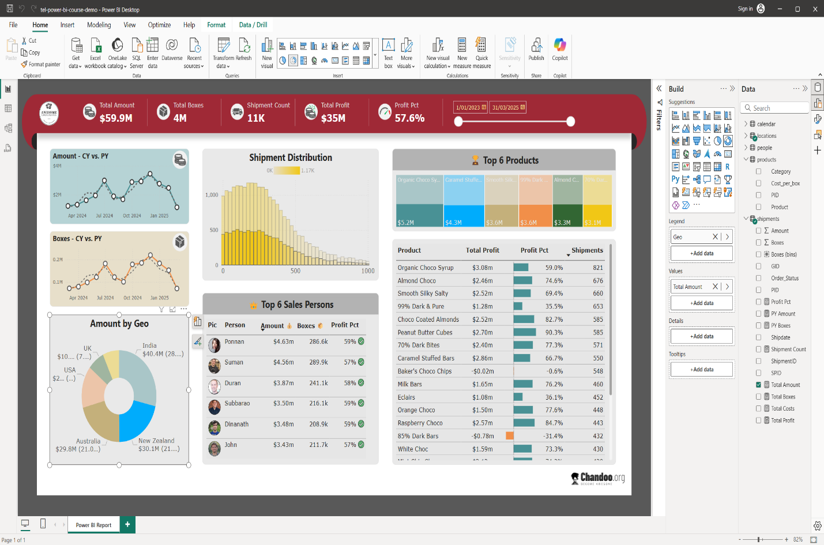
Summary:
The business is performing strongly, driven by top regions, products, and employees. However, there are strategic opportunities to address unprofitable products and weaker international markets to sustain long-term growth

